**Nama : Elvy Rahmatillah Imami**

**NIM : L200170041**

**MODUL 6**

**Kegiatan 1 Topologi 1**

1. Menggunakan Packet Tracer buat topologi berikut ini dengan menggunaan switch Catalyst 2950.

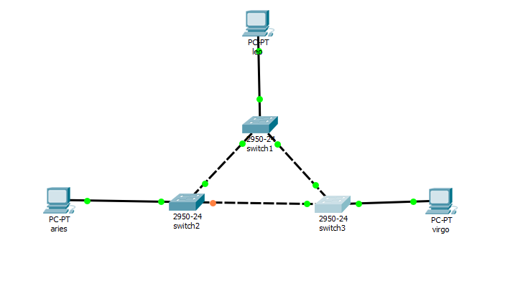

Langkah pembuatan topologi :

Pilih semua bagian (PC, Switch) kemudian hubungan dengan kabel.

1. Beri nama masing-masing switch dengan SW1, SW2, SW3

Langkah penamaan switch :

Klik pada switch, kemudian ganti nama pada switch dengan SW1, SW2, SW3.

1. Konfigurasi masing-masing PC dengan alamat IP.

* Leo = 172.21.1.1/24
* Aries = 172.21.1.2/24
* Virgo = 172.21.1.3/24

1. Pada mode user atau mode privileged, lihat status STP pada masing-masing switch.

Switch 1

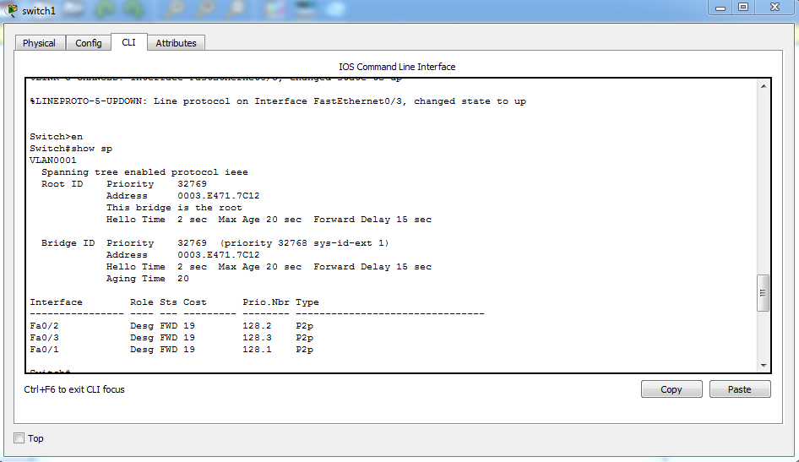

|  |  |  |
| --- | --- | --- |
| No. | Variabel | Nilai |
| 1. | Root ID | 32769 0003.E471.7C12 |
| 2. | Priority | 32769 |
| 3. | MAC Address | 0003.E471.7C12 |
| 4. | Bridge ID | 32769 0003.E471.7C12 |
| 5. | Cost (0/1, 0/2, 0/3) |  |
| 6. | Hello Time | 2 |
| 7. | MaxAge | 20 |
| 8. | Forward Delay | 15 |

|  |  |  |  |
| --- | --- | --- | --- |
| Interface | Role | Status | Cost |
| 0/1 | Desg | FWD | 19 |
| 0/2 | Desg | FWD | 19 |
| 0/3 | Desg | FWD | 19 |

Switch 2

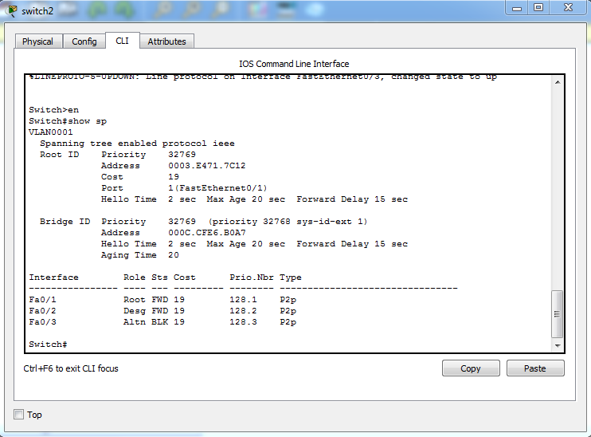

|  |  |  |
| --- | --- | --- |
| No. | Variabel | Nilai |
| 1. | Root ID | 32769 0003.E471.7C12 |
| 2. | Priority | 32769 |
| 3. | MAC Address | 0003.E471.7C12 |
| 4. | Bridge ID | 32769 0003.E471.7C12 |
| 5. | Cost (0/1, 0/2, 0/3) |  |
| 6. | Hello Time | 2 |
| 7. | MaxAge | 20 |
| 8. | Forward Delay | 15 |

|  |  |  |  |
| --- | --- | --- | --- |
| Interface | Role | Status | Cost |
| 0/1 | Root | FWD | 19 |
| 0/2 | Desg | FWD | 19 |
| 0/3 | Altn | BLK | 19 |

Switch 3

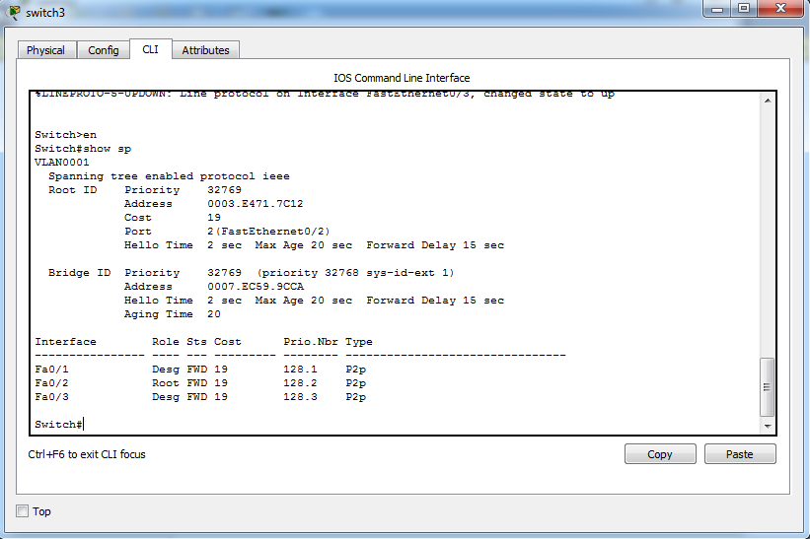

|  |  |  |
| --- | --- | --- |
| No. | Variabel | Nilai |
| 1. | Root ID | 32769 0003.E471.7C12 |
| 2. | Priority | 32769 |
| 3. | MAC Address | 0003.E471.7C12 |
| 4. | Bridge ID | 32769 0003.E471.7C12 |
| 5. | Cost (0/1, 0/2, 0/3) |  |
| 6. | Hello Time | 2 |
| 7. | MaxAge | 20 |
| 8. | Forward Delay | 15 |

|  |  |  |  |
| --- | --- | --- | --- |
| Interface | Role | Status | Cost |
| 0/1 | Desg | FWD | 19 |
| 0/2 | Root | FWD | 19 |
| 0/3 | Desg | FWD | 19 |

Pada kondisi default tersebut, switch dan port mana saja yang :

* Menjadi *root bridge* : SW1 (0/1, 0/2, 0/3)
* Menjadi *designated bridge* : SW1 (0/1, 0/2, 0/3), SW3 (0/1, 0/3)
* Menjadi *root port* : SW3 (0/2)
* Menjadi *designated port* : SW1 (0/1, 0/2, 0/3), SW2 (0/2)

Pada kondisi default tersebut, dan port mana saja yang :

* Berada pada keadaan *forwarding* : SW1 (0/1, 0/2, 0/3), SW3 (0/1, 0/3)
* Berada pada keadaan *blocking* : SW2 (0/3)

1. Lakukan ping dari PC leo ke PC virgo

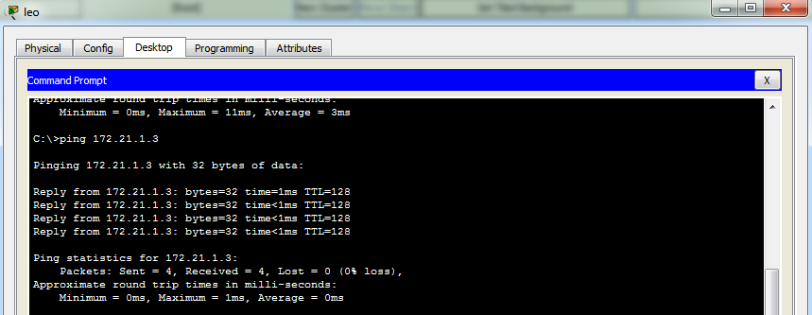

1. Simpan konfigurasi jaringan dengan nama lab2.nwc

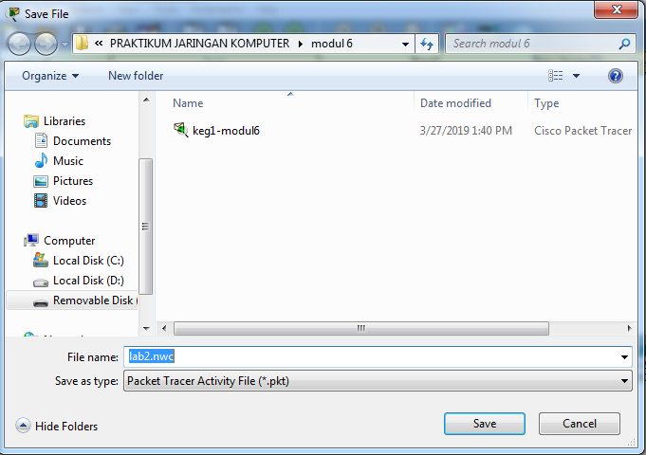

**Kegiatan 2 Topologi 2**

1. Menggunakan Packet Tracer ubah topologi menjadi topologi berikut ini :

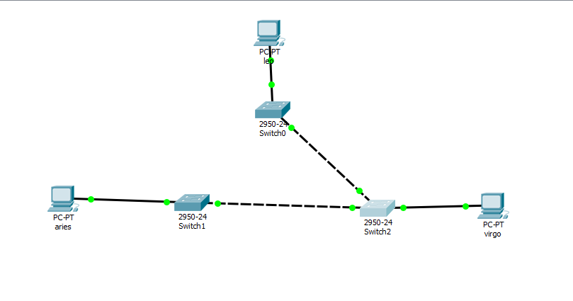

1. Beri nama masing-masing switch dengan Switch0, Switch1, Switch2

Langkah penamaan switch :

Klik pada switch, kemudian ganti nama pada switch dengan Switch0, Switch1, Switch2.

1. Konfigurasi masing-masing PC dengan alamat IP.

* Leo = 172.21.1.1/24
* Aries = 172.21.1.2/24
* Virgo = 172.21.1.3/24

1. Pada mode user atau mode privileged, lihat status STP pada masing-masing switch.

Switch0

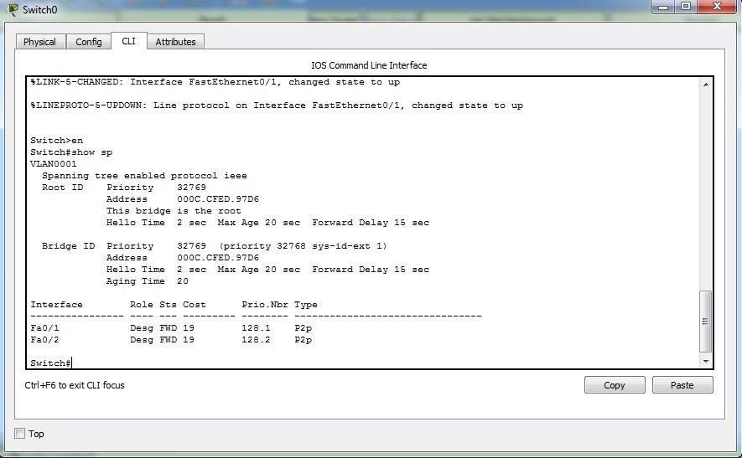

|  |  |  |
| --- | --- | --- |
| No. | Variabel | Nilai |
| 1. | Root ID | 32769 000C.CFED.97D6 |
| 2. | Priority | 32769 |
| 3. | MAC Address | 000C.CFED.97D6 |
| 4. | Bridge ID | 32769 000C.CFED.97D6 |
| 5. | Cost (0/1, 0/2, 0/3) |  |
| 6. | Hello Time | 2 |
| 7. | MaxAge | 20 |
| 8. | Forward Delay | 15 |

|  |  |  |  |
| --- | --- | --- | --- |
| Interface | Role | Status | Cost |
| 0/1 | Desg | FWD | 19 |
| 0/2 | Desg | FWD | 19 |

Switch1

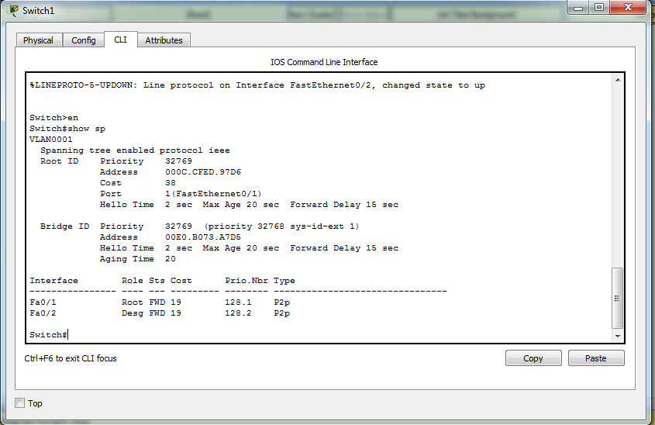

|  |  |  |
| --- | --- | --- |
| No. | Variabel | Nilai |
| 1. | Root ID | 32769 000C.CFED.97D6 |
| 2. | Priority | 32769 |
| 3. | MAC Address | 000C.CFED.97D6 |
| 4. | Bridge ID | 32769 000C.CFED.97D6 |
| 5. | Cost (0/1, 0/2, 0/3) |  |
| 6. | Hello Time | 2 |
| 7. | MaxAge | 20 |
| 8. | Forward Delay | 15 |

|  |  |  |  |
| --- | --- | --- | --- |
| Interface | Role | Status | Cost |
| 0/1 | Root | FWD | 19 |
| 0/2 | Desg | FWD | 19 |

Switch2

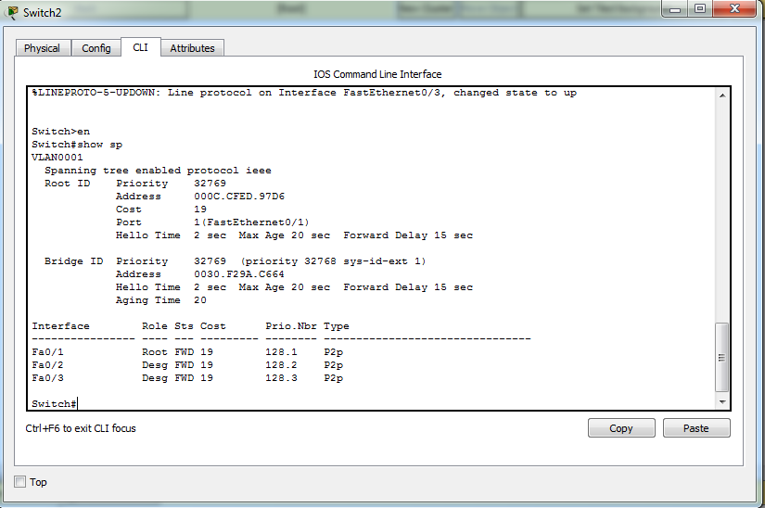

|  |  |  |
| --- | --- | --- |
| No. | Variabel | Nilai |
| 1. | Root ID | 32769 000C.CFED.97D6 |
| 2. | Priority | 32769 |
| 3. | MAC Address | 000C.CFED.97D6 |
| 4. | Bridge ID | 32769 000C.CFED.97D6 |
| 5. | Cost (0/1, 0/2, 0/3) |  |
| 6. | Hello Time | 2 |
| 7. | MaxAge | 20 |
| 8. | Forward Delay | 15 |

|  |  |  |  |
| --- | --- | --- | --- |
| Interface | Role | Status | Cost |
| 0/1 | Root | FWD | 19 |
| 0/2 | Desg | FWD | 19 |
| 0/3 | Desg | FWD | 19 |

Pada kondisi default tersebut, switch dan port mana saja yang :

* Menjadi *root bridge* : SW0 (0/1, 0/2)
* Menjadi *designated bridge* : SW1 (0/2), SW2 (0/1, 0/3)
* Menjadi *root port* : SW1 (0/1), SW2 (0/1)
* Menjadi *designated port* : SW0 (0/1, 0/2)

Pada kondisi default tersebut, dan port mana saja yang :

* Berada pada keadaan *forwarding* : SW0 (0/1, 0/2), SW1 (0/1, 0/2), SW2 (0/1, 0/2, 0/3)
* Berada pada keadaan *blocking* : -

1. Lakukan ping dari PC leo ke PC virgo

